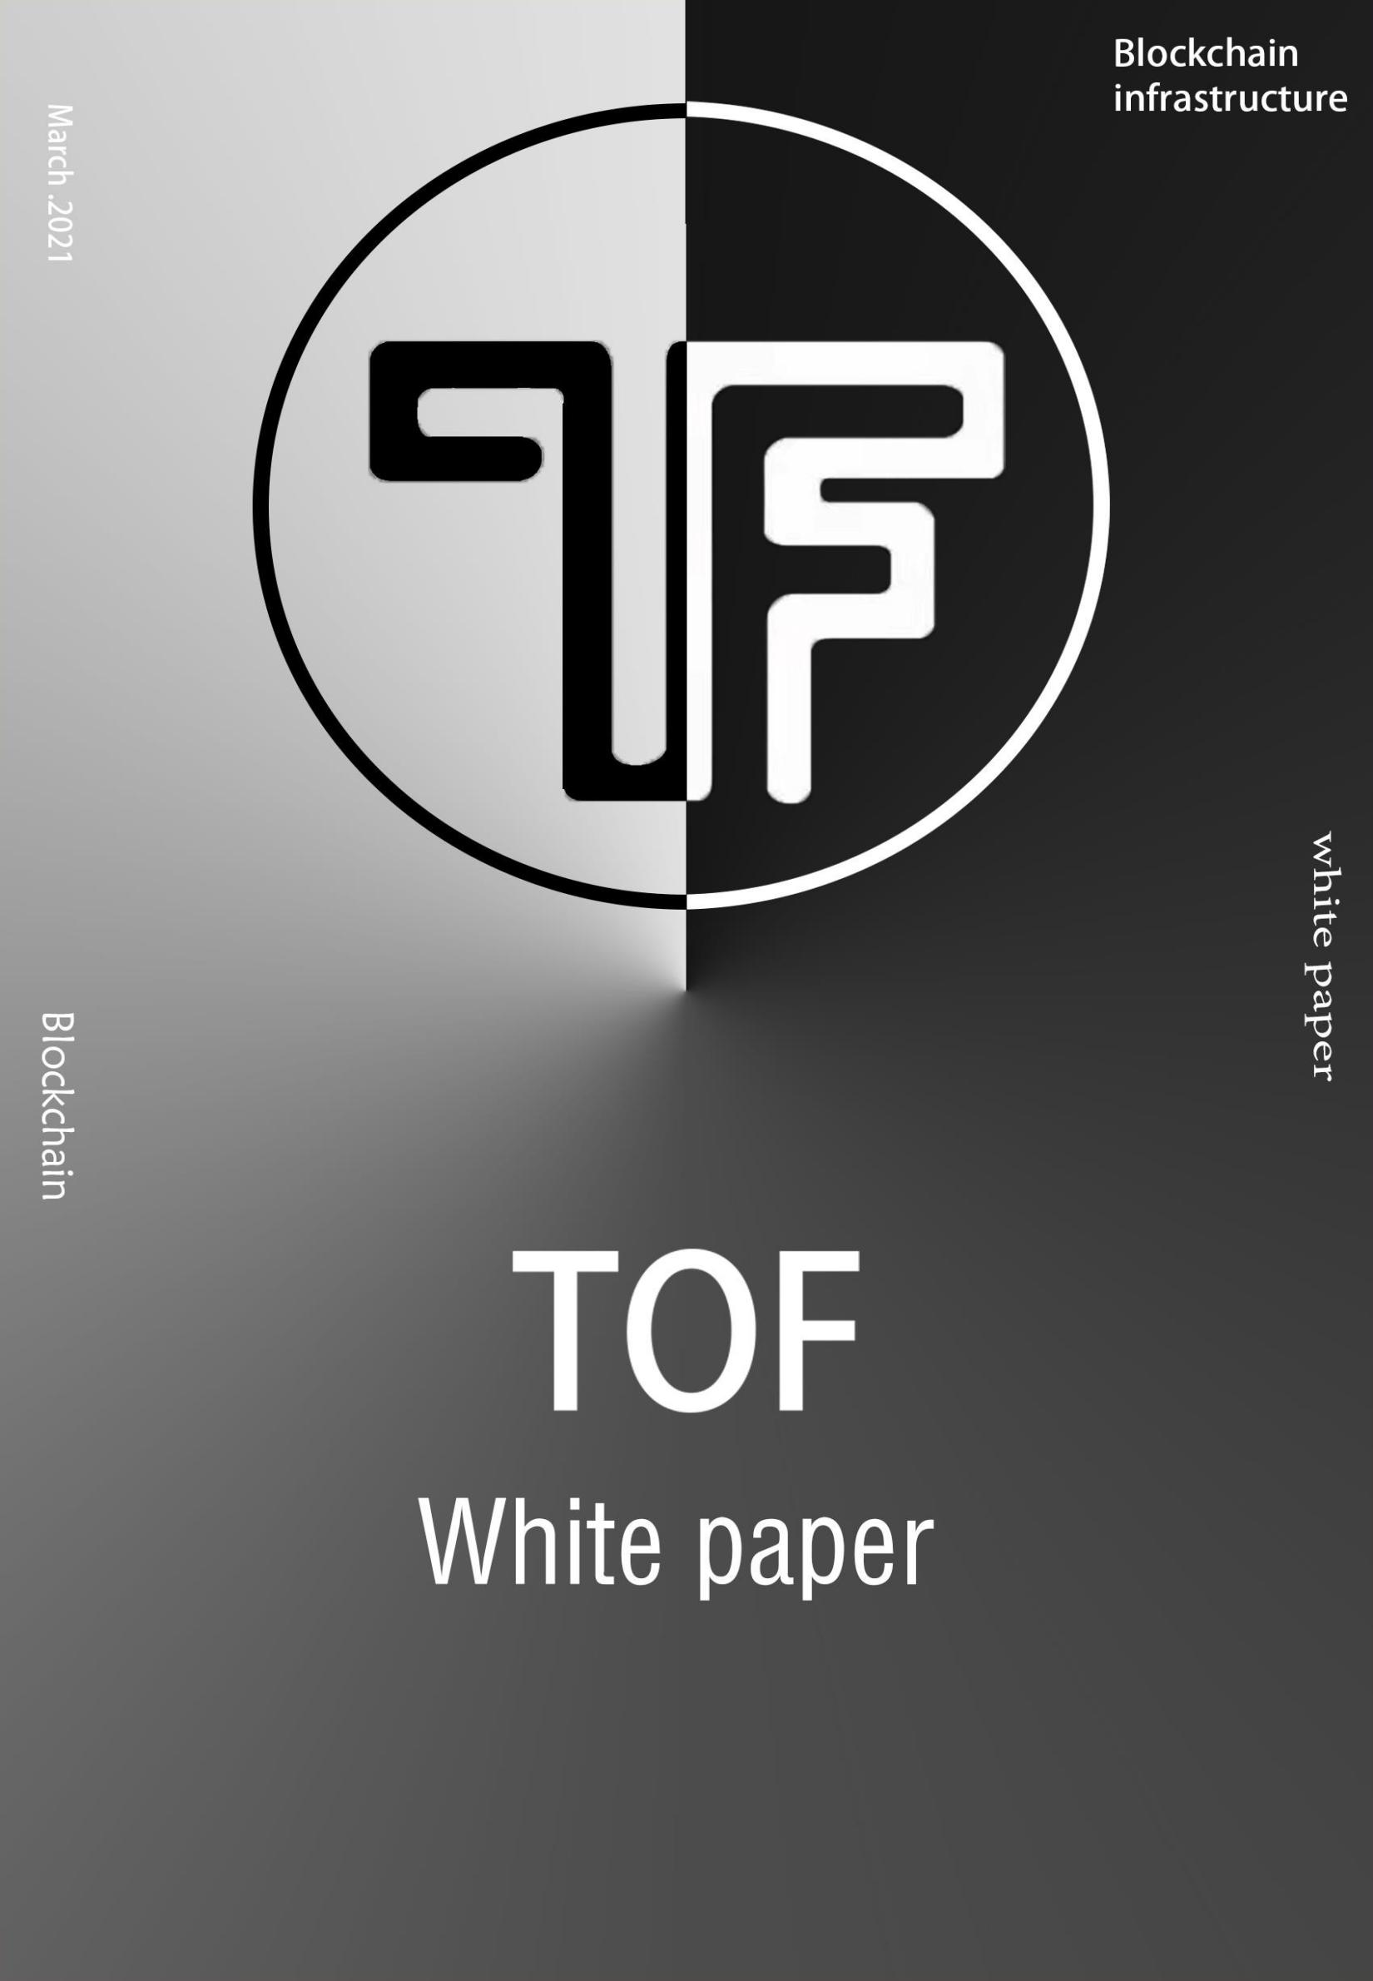



Abstract

If the Internet is the third revolution of human productivity, then the blockchain that we are

experiencing may be a new revolution. The

characteristics of blockchain, such as decentralization, point- to- point transaction, traceability mechanism and smart contract, are expected to solve the " stubborn

disease" that traditional Internet technology can not

cure. Since the birth of bitcoin, blockchain technology

has been continuously fermenting, and some

application service platforms focusing on blockchain

have also entered the public field of vision, while TOF has made blockchain simpler 。

TOF is a global blockchain open source community project, which is a blockchain infrastructure providing

customized services. TOF has developed a set of

technical standards for industrial blockchain, following the principles of hot plug, modularization and parallel expansion, providing scalable functional modules such as consensus, network, account book, account, block management, chain management, transaction

management and event bus.



We believe that in this era of rapid economic development, blockchain technology, with i ts

characteristics of decentralization, tamper proofing,

and high transparency, will become another technology that innovates human society after PC Internet and

mobile Internet, and will make the t rust of various social relations easier.

At present, blockchain technology is still in the initial stage of exploration, but it has shown good application prospects in various industries. In the

future, more and more blockchain technologies and applications will come into all aspects of our real

society. Blockchain is a kind of technology. What TOF should do is to reduce the development cost of

blockchain and promote the implementation of

commercial applications of blockchain. Let users get

benefits, at the same t ime, let the block application go to every household and all walks of l i fe, provide a new entrepreneurial opportunity for mankind, create a

perfect and brand- new blockchain ecological platform, and provide users with the best quality and convenient services.



Under the impact of the blockchain era, the application field will usher in new challenges and opportunities.

The blockchain service created by TOF based on blockchain technology constitutes a complete

sustainable development ecology that can truly provide blockchain One- stop service will surely become an

industry giant in the application field of the blockchain era.

Catalog

|  |  |  |
| --- | --- | --- |
| **P1** |  | **1.The future of blockchain** |
| **P3** |  | **2.About TOF** |
| **P6** |  | **3.Technology** |
|  | **P6** | **3 . 1 Mi cro se rv i ce a r c h i te ctu re** |
|  | **P9 P 1 3**  **P 2 0**  **P 2 7**  **P 3 1** | **3 . 2 Con sensu s m e c ha ni sm**  **3 . 3 T OF o p e n s o u rc e p u b l i c c h a i n 3 . 4 T OF s ma r t c o n t ra ct**  **3 . 5 Cro ss c h a i n**  **3 . 6 S ec ur i t y** |

**P33 4.Application scenarios of TOF**

**P 3 3 4 . 1 P ro v i d e f l e x i b l e a n d e a s y- to - u s e**

**b l o ckc hai n i n f ra st ru c tu re**

**P 3 4**

**P 3 5**

**4 . 2 S up po r t m a s s i ve b l o c kcha i n a p p l i ca t i o ns 4 . 3 Dr i v i n g b l o ck c h ai n c o mmerc i a l l a n d i ng**

**P36 5.Ecological construction P38 6.Distribution plan**

**P40 7.Government**

**P41 8.Risk tips**

# The future of blockchain

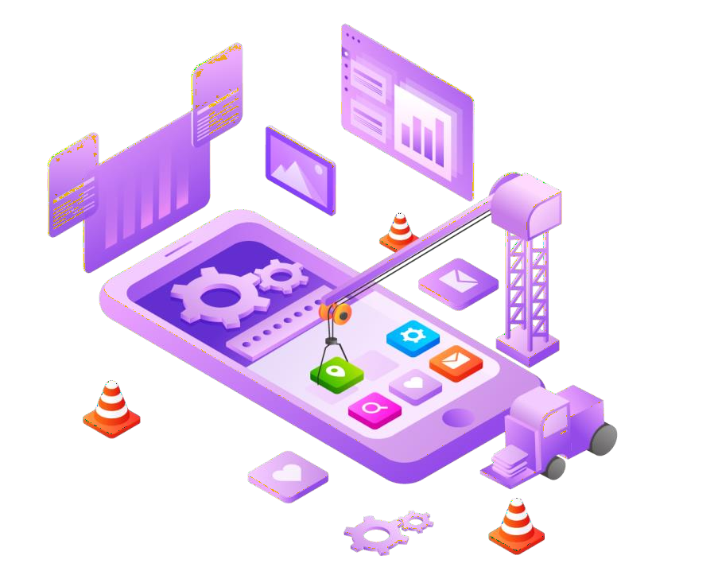

In the process of human socialization, the society progresses and changes in the form of survival of the fi ttest. From the ancient stone age to today' s Internet and sharing economy era, the emergence of each core technology will greatly solve the problems of

production, economy and communication in the current society, and promote social progress.

## 1



With the rapid development of society and the

progress of science and technology, the situation of unreliable information and lack of credit resources is becoming more and more serious, the t rust system

among the government, enterprises and individuals is becoming more and more fragile, and the cost of

communication and transaction is increasing rapidly.

In 2008 , Nakamoto f i rst proposed the concept of

blockchain. In recent years, the development speed of blockchain is far beyond our imagination, and many

branches based on blockchain technology also provide great convenience for our l i fe. However, there are a

series of problems in the development of blockchain,

such as security, cost, landing construction and so on,

which hinder i ts development. The emergence of TOF will

greatly improve this status quo. Through the complete

infrastructure integration capabilities and strong resource support, TOF will surely boost the long - term development of the blockchain..

## 2



About TOF

TOF is a blockchain infrastructure that provides

customized services and is an open source ecological public chain of global blockchain. It is jointly

developed by blockchain elites and technology geeks all over the world. TOF adopts the idea of micro

service, realizes a highly modular underlying

architecture, uses technologies such as smart contract

and cross chain, and combines the ability of chain

factory to quickly build the chain, so as to reduce the development cost of blockchain and promote the

implementation of commercial application of blockchain.

## 3



TOF adopts the idea of micro service, realizes a highly modular underlying architecture, and uses

module warehouse, intelligent contract and cross chain technology to reduce the development cost of

blockchain. TOF puts forward the micro service architecture of modular thinking and multi chain parallel, adheres to the development concept of

" chain" as the core, and creates the core product " chain factory". Based on TOF, users can f lexibly

select network module, consensus module, storage module, account module, smart contract and other

core function modules to create a new blockchain in

TOF network. They can also define their own business

logic through smart contract with l i t t le programming

work.

## 4



TOF believes that blockchain will exist as the

basis of enterprise application in the future because of i ts technical characteristics of distributed storage,

openness and transparency, and the ability to t ransfer value. However, so far, it is difficult to find that an

application or project around us is really based on

blockchain technology.

Part of the reason for this phenomenon is that

blockchain is a combination of various technologies, which requires high capabilities of developers;

blockchain technology is still in the early stage of development, and there is no mature underlying

f ramework, modules, etc. that can be directly used, nor a set of technical standards that can be followed. This

results in the long development cycle and difficulty of blockchain. In order to solve these problems and

promote the implementation of blockchain commercial applications, TOF came into being.

## 5



Technology

* 1. Microservice architecture

TOF takes the lead in the layout of microservice architecture, introduces the idea of microservice into the design of the underlying infrastructure of

blockchain, and divides the software into multiple

independently deployable services. TOF introduces

this advanced design idea of software engineering into module design, so that each module can be as flexible as an independent program, and the development of a single module can support multiple programming

languages.

## 6

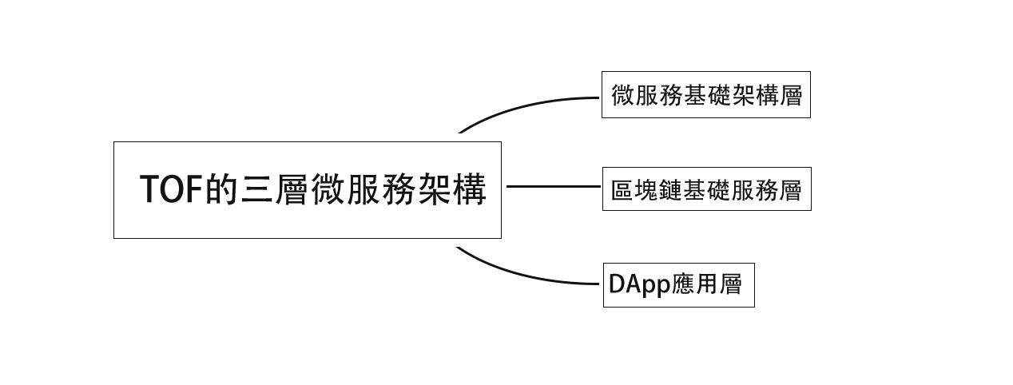

* + 1. Three layer microservice architecture of TOF

The f i rst layer is the micro service infrastructure layer;

The second layer is the basic service layer of blockchain;

The third layer is DAPP application layer.

## 7



This architecture enables developers to develop

more advanced application systems on the second layer ( for example, the distributed system of the

exchange and the data service system can be built on the second layer). Building on the TOF system, not

only multiple chains and dapps, but also other large, medium and small- sized Internet without blockchain.

## 8

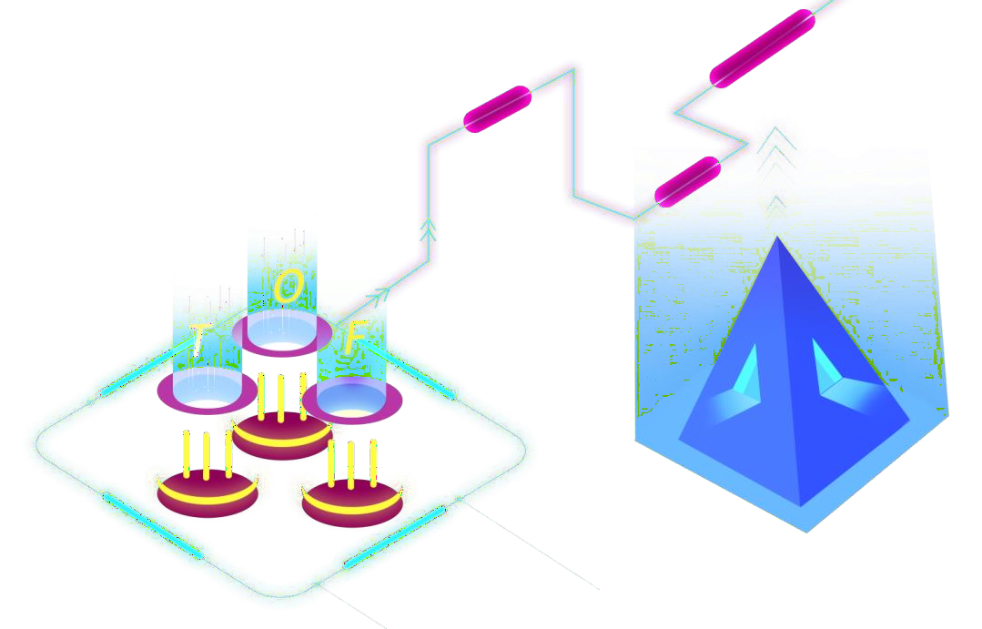

* 1. Consensus mechanism
     1. POC

The modular design of TOF supports the

replacement and plugging of all core function modules including consensus mechanism. The main network of TOF adopts POC ( proof of credit) by default. When the

node' s credit is up to the standard, a certain number of TOF can be locked to join the consensus. After the

consensus nodes are reordered, the blocks will be

released in turn in each round, and the locked TOF will be unlocked when they exit the consensus.

## 9

* + 1. Consensus entry and exit

mining mechanism

Anyone can join the consensus of TOF at any t ime.

As long as they meet the conditions and abide by the rules, they can continue to get toftoken rewards. POC can be divided into hard index and soft index. Hard

index means that the credit score must reach a certain standard l ine, excluding some nodes that have done

evil. Soft index means that a certain amount of TOF must be locked as a deposit. In order to stop the

flooding of nodes and make the whole system more fair, the number of locked TOF is l imited by a minimum

value, and anyone can choose freely. The number of locked TOF will be l inked with the final reward.

## 10



* + 1. Common consensus mechanism

TOF is a set of general basic infrastructure of

blockchain. It does not run any application services on

i ts main network, and all application services are run

by parallel blockchain. Through TOF chain factory

products, blockchain based on module warehouse can be deployed quickly, and various operation parameters can be flexibly customized, including whether basic

token, encryption algorithm, consensus mechanism and storage mechanism are supported.

TOF defines a common consensus module to

provide a common understanding mechanism for

interface compatibility. TOF community will develop

consensus mechanisms such as pow, dpos, POS, pbft, pool verification pool for users to choose freely.

## 11



* + 1. Consensus reward

For the balance and fairness of the whole TOF

network, consensus reward is calculated according to the deposit and credit of all consensus nodes.

## 12

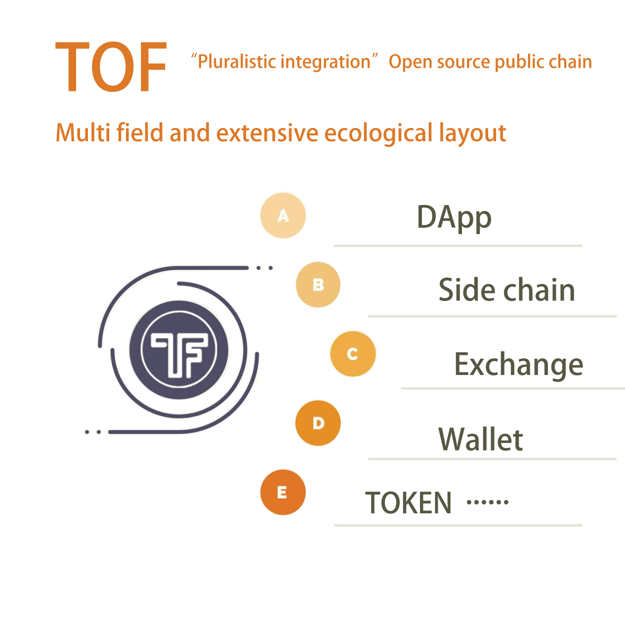

* 1. TOF open source public chain

TOF public chain aims at the development

direction of " multi- dimensional integration", with app, token, exchange, wallet, side chain and community as

the development route. TOF will develop in the form of commercial chain, including technology open source,

exchange, implementation of landing application,

development of enterprise side chain, combination of cross chain wallet, creation of super community,

establishment of DAPP, etc.

## 13



The ecological improvement of TOF is conducive to the landing of application scenarios. Through the independent public chain, the effective protection of users' rights and interests does not rely on the third-

party platform. Through the main network ecology, TOF can produce better network economic effect and

realize more commercial applications and landing

scenarios. With the continuous expansion of the main network, users can get more value f rom i t. In addition to technology, TOF has also carried out a multi- level and multi field ecological layout around the world, and has begun to take shape.

## 14

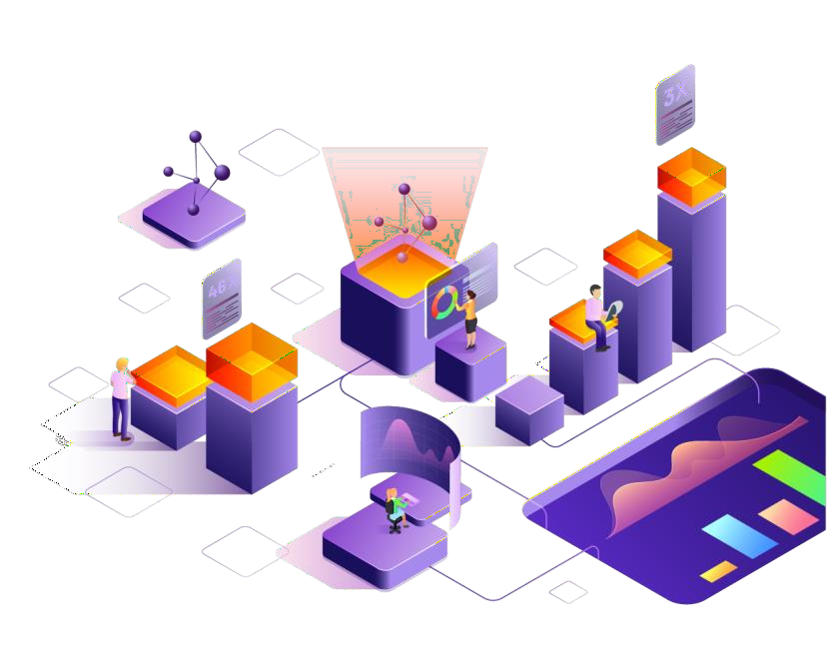

* + 1. What is open source

Open source refers to the project follows the open source agreement, the source code is open, anyone

can view. In the early stage of computer development, software was almost open, and anyone could view the source code of the software. However, the emergence of Microsoft broke this situation, and they no longer

attached the source code when distributing the

software. From then on, the era of proprietary software came. However, with the emergence of blockchain

technology, characterized by open source code, and

with the huge recognition in the geek circle, it began to re- enter the stage of history. Now most of the projects choose to open source on Git Hub. As a global open

source public chain, TOF has also adopted the completely open source approach.

## 15



* + 1. Advantages of TOF open source

Fewer project vulnerabilities

TOF chooses open source, which means that it will

bear greater public pressure and accept public

inspection. When the TOF team is writing and testing code, it will pay more attention to code quality and

feasibility, which greatly reduces the occurrence of loopholes.

Lower development costs

As the open source community matures, TOF will hand over some work to community members, such as project vulnerability checking and code writing. In this way, the overall development cost will be lower and

lower, and TOF will have more resources to give back

to users.

## 16



Stronger innovation ability

With the continuous development of TOF

community in the direction of diversification, the

innovative ideas of technical talents can directly create

their own branches. Open source gives them more

choices, and also provides f resh blood for TOF. With stronger creativity, TOF can provide users with more

and better services, which is a benign and sustainable perfect circle.

## 17



* + 1. TOF public chain solution

TOF has built a new layer 2 protocol on the main chain of the public chain. Developers can use the open- source microservice tools of TOF to transplant

mobile apps or web applications such as e- commerce, o2o, social networking and search to Ethereum, Boca

and other chains, build decentralized application DAPP,

and establish decentralized governance organization

DAC ( decentralized company).

The core of the two- layer agreement of TOF is the game mechanism of pledge withdrawal based on the

idea of optimal rollup and or side chain, namely, optimal governance. To match with this game

mechanism, TOF makes a hard bifurcation of optimal

rollup, constructs a TOF virtual machine, and manages and computes the business and data layers through

the corresponding management f ramework deployed on the side chain.

## 18



At the same t ime, TOF provides a mortgage

mechanism to solve the t rust problem of decentralized organizations. Participants participate in governance

through mortgage mechanism. Once participants cheat, the Internet will punish them by deducting collateral.

## 19



* 1. TOF smart contract

From the perspective of module structure, the TOF smart contract module is located between the external service module and the underlying facilities module

( such as network module, storage module, account module, etc.), and the account module, network

module and other modules provide the underlying support for the smart contract.

## 20



* + 1. Standardization

Intelligent contracts are divided into two types:

one is legal and practical smart contract; the other is chain code, which is just the code running on the

blockchain, and has no legal effect. The f i rst kind of

contract is also called " legalsmartcontracts" in foreign countries, so as to distinguish the code on the chain without legal effect. TOF has always used " smart

contract" and " chain code" to distinguish between these two mechanisms. TOF focuses on smart

contracts rather than code on the chain.

TOF thinks i t is unwise to translate the existing financial transaction process into code directly.

Because part of the existing process is manual

operation, in order to maintain the flexibility of the process. But if these manual processes are also

automated, this process needs to be very r igorous

analysis. Because once automated, the " f lexibility"

must be embedded in the code of the smart contract, otherwise problems may arise.

## 21



The emergence of TOF has opened up a broader

field of knowledge research on Intelligent contract, and is also a new cross research topic. This topic includes three fields, law, finance and computer. This work is

based on law, but it needs to be implemented in computer modeling language, system and

infrastructure. In modeling, financial knowledge and legal knowledge are the main factors, but later it is realized by computer. From the compliance process,

gradually approach the legal intelligence contract, and

finally realize the legalization of the intelligent contract.

## 22



* + 1. Systematization

TOF smart contract can be embedded in legal

terms, machine readable or readable as ordinary text

books by using legal terms f rom the legal point of view, so that lawyers and contractors can easily read the

contract and negotiate with the law. The advent of blockchain undoubtedly creates a development

platform for TOF contract, and the witnesses, buyers and sellers, financial institutions and regulatory

departments involved in the contract need to be used

as the user area on the chain to realize the contract.

TOF decomposes the process of smart contract development: in the past, smart contract operation

circumvention supervision system was mainly based on code f rom development to completion. The contribution of TOF contract is to develop compliance smart

contract, which is divided into two parts:

## 23



Firstly, a compliance smart contract template

model is established. After these template models are verified, they are valuable intellectual property rights;

Use the developed template to create code ( such

as automatic code generation or manual development).

Therefore, " writing contract" will change to

" modeling f rom contract template to contract model", which is the innovation and advantage of TOF.

## 24



* + 1. Framework

Transmission principle: TOF contract data must

come f rom the blockchain. Even if the data comes f rom the Oracle, the data must be stored on the blockchain before it can run in the smart contract system.

However, the data used by the smart contract can

come f rom different blockchain systems, but each data has data source ( digital ID card of the t ransport chain) and t imestamp information.

Calculation principle: there is a consensus on TOF

contract calculation and has i ts own blockchain system.

## 25



Write back principle: TOF contract calculation

results can exist on different blockchains. Since the consensus of the contract system may not be carried out on the storage chain, this write is equivalent to a

new " write" operation, and the data will be saved after the consensus of the storage chain. Each data written back also has data source ( digital ID card of the

computing chain) and t ime stamp information.

Based on the above new three principles of smart contract ( for many to many Architecture), it can ensure the authenticity and validity of data sources, the

accuracy of calculation results and the preservation of final data.

## 26



* 1. Cross chain

The blockchain based on the TOF module

warehouse ( the ecological blockchain) can add cross chain modules through module selection to realize the interworking between the bottom layer and TOF.

For Ethereum and bitcoin, following the public chain with different protocols f rom TOF, we need to implement protocol conversion through special

mechanism, and adapt other public chain protocols to TOF cross chain protocol, so as to achieve the

purpose of unified protocol communication.

The assets in each block chain can flow to any

chain in the TOF ecosystem that receives the t ransfer of assets f rom the external chain through cross chain, and i t only costs a small price.

## 27

* + 1. Technical characteristics of

TOF cross chain

TOF main network uses POC consensus

mechanism and Byzantine fault tolerance mechanism

to realize cross chain transaction confirmation and packaging, so as to achieve decentralization,

performance and security.

Each node in the main network of TOF will connect multiple nodes of multiple blockchains. Because the

protocol is a unified definition of TOF cross chain

protocol, a single node can connect multiple nodes on different blockchains at the same t ime.

TOF main network provides chain management mechanism to manage all peer- to- peer blockchains registered in TOF main network. The contents of

registration include chain information, asset information, cross chain margin, etc.

## 28



When assets of other chains are received on one blockchain, corresponding assets need to be

generated in the chain. Tokens on different

blockchains are stored in other chains in the form of assets.

The details of assets t ransferred into other chains in one blockchain will be stored in TOF main network. When the asset is t ransferred out of the blockchain, it will be verified, and i l legal assets are not allowed to

be generated f rom the blockchain. For malicious

blockchain, it will be processed through community mechanism, such as temporary stop cross chain,

suspension cross chain, confiscate deposit, etc

TOF main network will provide API user manual, any developer can develop their own wallet, browser, l ight wallet and other tools according to the manual..

The extension of protocol supply is provided in TOF main network, which can be used to develop DAPP and optimize cross chain protocol.

## 29



The underlying layer of TOF network provides a complete distributed account system, including the complete intelligent contract system and security

system. Meanwhile, TOF network abstracts the

underlying complex technical system and architecture system, realizes distributed entity management and multi- dimensional authentication protocol which

supports all kinds of main protocols and password

standards, and supports cross chain and cross system

interaction mapping of various heterogeneous

blockchains and traditional information systems.

TOF network also provides such technical systems as secure data storage, heterogeneous smart contract, hardware key management, encrypted data analysis,

etc. As an application platform, the whole network can support the construction of various application

services, especially decentralized applications. On this basis, ontology network provides a series of

application f rameworks, including distributed data

exchange protocol, distributed process management protocol and so on. Through common API, SDK and various application function components, it further

supports the implementation of various upper layer applications.

## 30



* 1. Security

TOF public chain has been further improved on the

basis of public and private keys. TOF ecology adopts

dynamic encryption method, all data of users will be

encrypted and stored, and only users can see i t. At the same t ime, TOF Ecological Institute also provides

encryption middleware services, users can choose according to business needs. Finally, in the upper

application, TOF ecology also encrypts the input data in real t ime, so no one can read i t.

In the future, TOF public chain Ecological Institute will also access digital wallets. In order to ensure the security of users' digital wallets, the wallets accessed by TOF public chain Ecological Institute will adopt the way of cold and hot separation. Most of the assets of TOF users are stored in the cold wallet, which is very secure. Only the user can store and extract them

through the private key. In terms of hot wallets, even if users only store a small amount of digital assets, they don' t have to worry about hacker attacks, because TOF public chain has improved i ts traditional operating

system, interaction protocol with the outside world, and server.

## 31



Of course, the most important point is that TOF public chain ecology adheres to the principle of

decentralization, which can ensure that i ts ecology

does not rely on any intermediary. At the same t ime, the super node voting system adopted by TOF public chain ecology will also immediately supervise

malicious nodes, ensure the operation safety of TOF

ecology, and further ensure the safety of users' digital assets of TOF ecology.

## 32

Application



scenarios of TOF

With fully independent technology and mature

operation concept, TOF will be well used in a series of scenarios such as the construction of infrastructure,

blockchain application and blockchain commerce of LAS.

# Provide flexible andeasy-to-use blockchain infrastructure

TOF provides a variety of modules for developers and users. Developers and users do not need to study the underlying technical details such as cryptography, consensus mechanism, storage mode, etc., but directly select the required modules f rom the module

warehouse of the chain factory according to their business and configure the parameters, so as to

quickly build a blockchain and reduce the commercial cost of blockchain.

## 33

* 1. Support massive blockchain



applications

At the application level, it can be expected that the application based on blockchain will gradually enter the work and l i fe of institutions and even

individuals. TOF provides the ability of fast chain building through modularization, provides the

circulation ability of data and assets between different blockchains through cross chain technology, and

provides Turing' s complete programmable ability

through smart contract, which can support various application scenarios in the future.

## 34

* 1. Driving block chain

commercial landing

Commercial applications have high performance

requirements. TOF is committed to solving the problem of l imited performance of existing blockchains. It uses parallel extension technology to build multiple

independent chains through chain factories and distribute services to each chain. Cross chain

technology is used to communicate between chains to

meet the demand of tens of millions of TPS.

## 35

Ecological



construction

The TOF team absorbed the advantages and

experience of the head exchange, and made

innovation and improvement on this basis. In order to connect with mature products in the industry, the TOF team has successively invested in Polkadot parachain, Cosmos IBC, etc. to carry out cross chain cooperation with multiple public chains, creating a cross chain

ecology with TOF as the core. For developers who

want to quickly access the ecosystem, TOF has also

launched corresponding products, which enables

developers to quickly develop their own public chains, participate in future TOF parallel chain auctions, and easily realize cross chain interoperability with popular public chains such as Polkadot and cosmos after

access.

In addition, TOF has also launched a complete set of blockchain infrastructure solutions based on i tself,

including asset cross chain, stable currency, security, swap, farm, lending, etc. Any user can easily

participate in cross chain, trading, lending, mortgage, synthetic assets, test the latest ideas, enrich the

ecology.

## 36



TOF is a high- performance open- source public chain, which has a unique insurance account

mechanism, innovatively solves the problem of user

asset theft and damage. The infrastructure with a high throughput of 2000 tps lays a solid foundation for the platform ecology, supports thousands of consensus

nodes, and is a t ruly decentralized public chain.

The low gas cost of TOF public chain solves the problem of high t ransfer fee of Ethereum, and the

throughput of Ethereum is 100 times, which provides broad space for blockchain like applications.

## 37

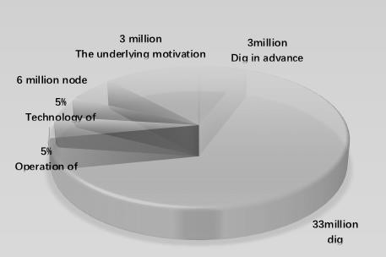

Distribution plan

**50 million TOF allocation plan**

1 : 3 million pre- excavation

2 : 33 million mining, 10 years every two years 30 % reduction 3 : Technology accounts for 5 %

4 : Operation accounts for 5 %

5 : 6 million nodes

6 : bottom excitation 3 million pieces

## 38

6.1How to become a super node

Build the server independently, and the super node pledge is 150000 TOF, 300000 TOF and 500000 TOF

respectively. The super node can obtain gas, the main income source is the mining income obtained by the

super node pledged by TOF, and the super node can release and exit periodically.

TOF is a customized service- oriented blockchain

infrastructure, a global open- source public chain. TOF has enough circulating data community resources

before public chain mapping. Including 15 main node permanent maintenance system and strong ecological diversion planning. The master node can upload the

ecological contribution value independently, and obtain the gas generated in the whole network circulation

process as the incentive reward of ecological contribution.

## 39



Government

TOF intends to adopt a three-tier structure of community conference (online form), autonomous committee and

operation committee for operational governance: the

community conference is a conference of all TOF token holders (conducted on the Internet), and the community conference is the highest decision -making body for TOF projects, and TOF token holders Have the right to vote, vote, and be elected at community meetings. The TOF Foundation is the main body of TOF governance and is responsible for the community meeting. It is fully

responsible for implementing the resolutions of the

community meeting, selecting members of the operation committee, supervising the work of the operation

committee, safeguarding the rights of TOF token holders,

and promoting the TOF brand.

## 40



Risk tips

Except as set forth in this white paper, TOF makes no representation or warranty ( especially with respect to i ts merchantability and specific functions) with

respect to TOF or the project circular. The project

adopts the principle of voluntary participation, self risk, self responsibility and self cost.

There are risks in the development, maintenance and operation of TOF, some of which are beyond the control of TOF. In addition to other contents described in this white paper, users need to be aware of the

following risks and assess whether they have the ability to bear the following risks. During the

development of TOF project, there may be the following risks:

## 41



Inadequate information provision:

As of the publication date of this white paper, TOF is still in the development stage, and i ts philosophy,

consensus mechanism, algorithm, code and other

technical details and parameters may be updated and changed frequently. Although this white paper contains the latest key information of TOF, it is not absolutely

complete and will be adjusted and updated f rom t ime to t ime by TOF for specific purposes. TOF will t ry i ts best to provide members of the community with all

kinds of information about the development of the

public chain, but it can not ensure that all the

information is delivered to each pass holder in real t ime.

## 42



Risks related to judicial supervision:

Encrypted digital assets are being or may be

regulated by the competent authorities of different

countries. TOF may receive f rom t ime to t ime inquiries, notices, warnings, orders or determinations f rom one or more competent authorities, or may be ordered to

suspend or terminate any development or action

relating to TOF. TOF development, marketing, publicity or other aspects may be seriously affected, hindered or terminated. As the regulatory policy may change at

any t ime, the existing regulatory l icense for TOF in any

country may be temporary.

## 43



Source code upgrade:

The source code of TOF is open source and may be upgraded, amended, modified or changed by any member of the TOF community f rom t ime to t ime. No

one can predict or guarantee the accurate result of an

upgrade, amendment, modification or change.

Therefore, any upgrade, amendment, modification or

change may result in unforeseen or unexpected results, which may have a significant adverse impact on the

operation of TOF or the value of token.

## 44



Competition:

The underlying protocol of TOF is based on open source computer software. No one claims copyright or other intellectual property rights in the source code.

Therefore, anyone can legally copy, copy, remake,

design, modify, upgrade, improve, recode, reprogram or otherwise use the source code and / or underlying protocols of TOF to t ry to develop competitive

protocols, software, systems, virtual platforms or

virtual machines, so as to compete with TOF, or even catch up with or replace TOF. TOF has no control over this. In addition, there are and will be many

competitive blockchain based platforms competing with

TOF. Under no circumstances can TOF eliminate,

prevent, l imit or reduce such competitive efforts to

compete with or replace TOF.

## 45



Unexpected risk:

Blockchain technology is a rapidly developing

technology. In addition to the risks mentioned in this white paper, there may be some risks that have not been mentioned or anticipated by TOF team, or a

variety of risks that have been mentioned may appear in the form of combination.

## 46

